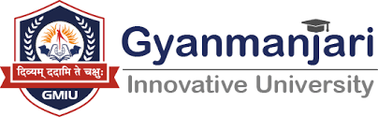

Gyanmanjari Institute of Management Studies Bhavnagar

Report on
Industrial Visit
___________________________________________
Date: | 02/07/2026
Duration: | 1 Day
Venue : | Aawadkrupa Plastomech Pvt. Ltd.

No. of Student | 100
Department | Management
Semester | 1
Faculty Co-Ordinator | Prof. Tulsi Kondhiya, Prof. Shruti Shah

Objective

The industrial visit to Aawadkrupa Plastomech Pvt. Ltd. Navagam, was organized with the objective of bridging the gap between theoretical learning and practical industry exposure. The activity aimed to provide students with first-hand insights into modern manufacturing practices, operational efficiency, supply chain management, quality control systems, and organizational workflow within a large-scale food processing enterprise. It was designed to enhance students’ industry awareness, strengthen their understanding of production and management concepts, and develop professional competencies aligned with current corporate and industrial standards.
About Activities:

The Training and Placement Activity (TPA) industrial visit to Aawadkrupa Plastomech Pvt. Ltd. Navagam, offered students an experiential learning opportunity through direct observation of real-time production processes and business operations. During the visit, students were introduced to automated manufacturing systems, hygiene and safety protocols, packaging techniques, and quality assurance mechanisms followed by the organization. Industry experts interacted with students, sharing practical insights on operational management, workforce coordination, and market positioning strategies. The visit enabled participants to connect academic concepts with real-world applications, thereby fostering industry readiness, professional exposure, and a deeper understanding of organizational functioning in a competitive business environment.
Photographs
